## Installation Procedure

### Server (One Time)

1. Go to ENOVIA server.
2. Go to Matrix and search for *SolidWorksInteg-GlobalConfig.*

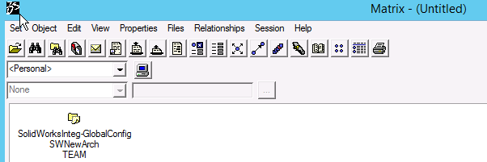

1. Right-click on the GCO and run *Properties => Attributes*.
2. Enter the following value for the *SLW-AddInRegistration* attribute:

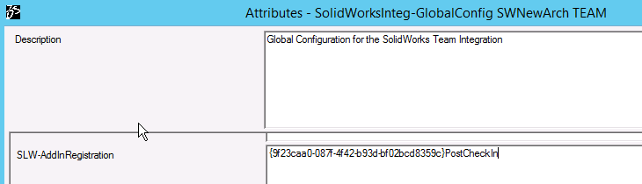

1. Click Modify.

### Client Machine (To be done on every client machine)

1. Extract the zip file named “SWAddInForCheckIn.zip“ and copy the folder to “C:\Program Files\SOLIDWORKS Corp\SWAddInForCheckIn”
2. Run cmd as Administrator and run the following command.

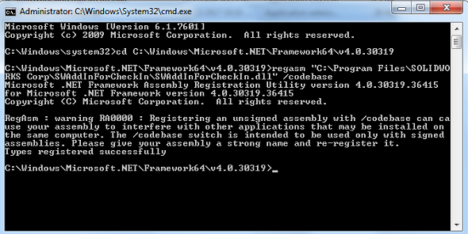

1. To setup Custom Properties templates, copy the “INVCustomProperties.asmprp” & “INVCustomProperties.prtprp” to path “C:\ProgramData\SolidWorks\SolidWorks 2017\lang\english”. Ensure that SolidWorks is pointing to the file locations of the Custom Properties by checking in “Options > System Options tab > File Locations > Custom Property Files”.
2. To setup SW Drawing Template, copy the “SDE - A3 – Landscape.drwdot” to path “C:\ProgramData\SolidWorks\SolidWorks 2017\templates”. Ensure that SolidWorks is pointing to the file locations of the Custom Properties by checking in “Options > System Options tab > File Locations > Document Templates”.
3. To setup BendLine macro, extract the zip file named “swBendline.zip“ and copy the folder to “C:\Program Files\SOLIDWORKS Corp\swBendline”. Run cmd as Administrator and run the following command.